**Working of the bot:**

In the core of working of our bot there is the one most important thing called Arduino which is handling the actual physical tasks of the bot.

Motor drivers are used to drive the motors and to make the bot mobile. The bot is made fully automated so that the user has very less amount of physical work. The user has to give inputs only through the 4x4 keypad and then bot do the rest of work very efficiently.

Let’s see the working of the bot in 3 different divisions as follows:

* Digging
* Seed sowing
* Levelling

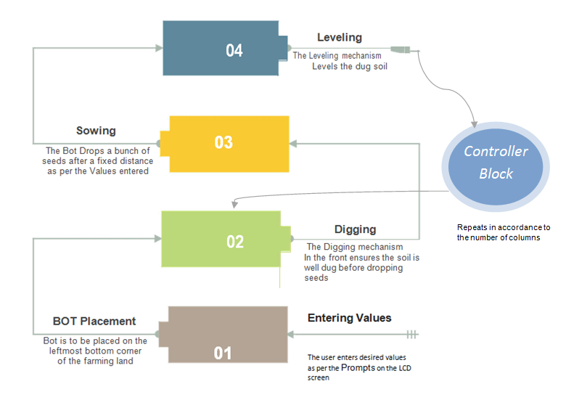

**Digging:**

It comes under secondary concern of our bot.in this part the bot actually digs the land and also make the safer zone for itself up to some extent. The digger which we are using is of steel material so it digs only some portion of the surface i.e. the only surface which is to be required for the seed to be sown.

**Seed sowing:**

It is the main working division of our bot. Under this all the things come right from taking the inputs to dropping seeds on the land. First of all we have worked on four different variables i.e. the person should enter that before actually running the bot. it contains

1. The distance between two seeds
2. The length of the column
3. The distance between two columns
4. Number of columns

The distance between two seeds is decided earlier so that it is programmed through Arduino that after the time set by user the seed should dropped periodically. Also the bot has to take turn when it goes towards the end of the column. That thing is obviously controlled by the Arduino. Finally when the last column comes then the bot should stop its functioning at the end of that column. For the seeds to be dropped we are using the disc as a obstacle to the seeds and we are storing it on bot itself. Its kind a perfect seed sowing mechanism for any user and it help him a lot.

**Levelling:**

The last and again the secondary concern is leveler. In that the bot finishes its work actually. The soil which is dig at the digging process and then the seeds are sown is all leveled by the leveler. It is type of roller attached to some support and mounted at the back of the bot which not only gives support to the bot but also carries its main functioning of leveling